OLA Electric:

* Home Page contains S1 and S2 poster with link to their dedicated page
* Both links are same, and these is separate website like ecommerce.

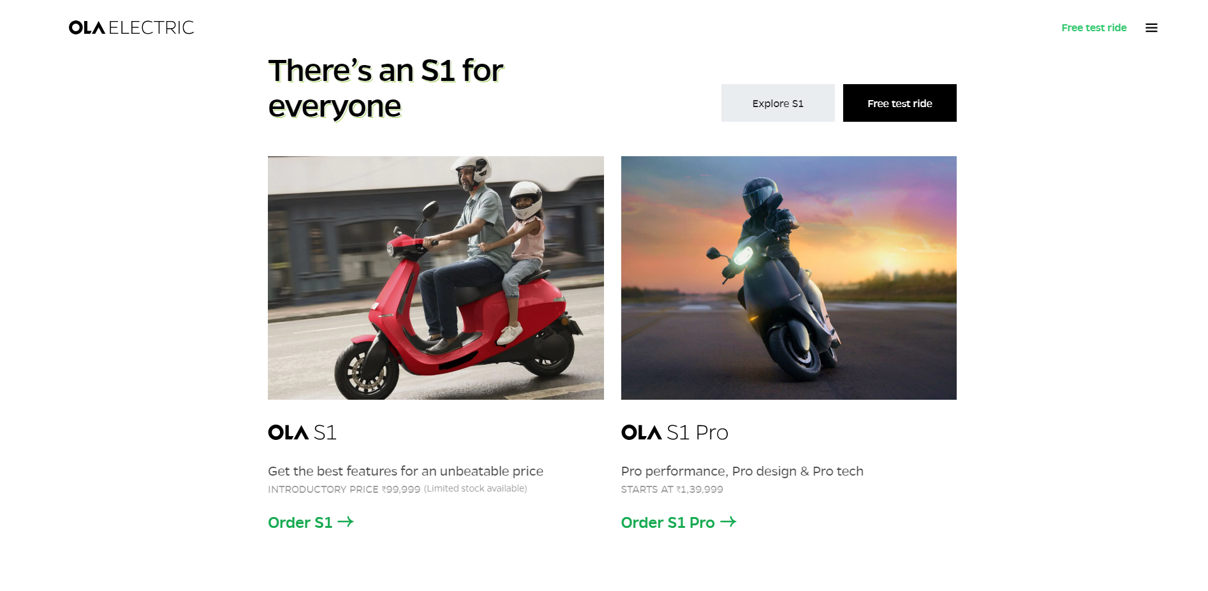

#Display -> Themes changer

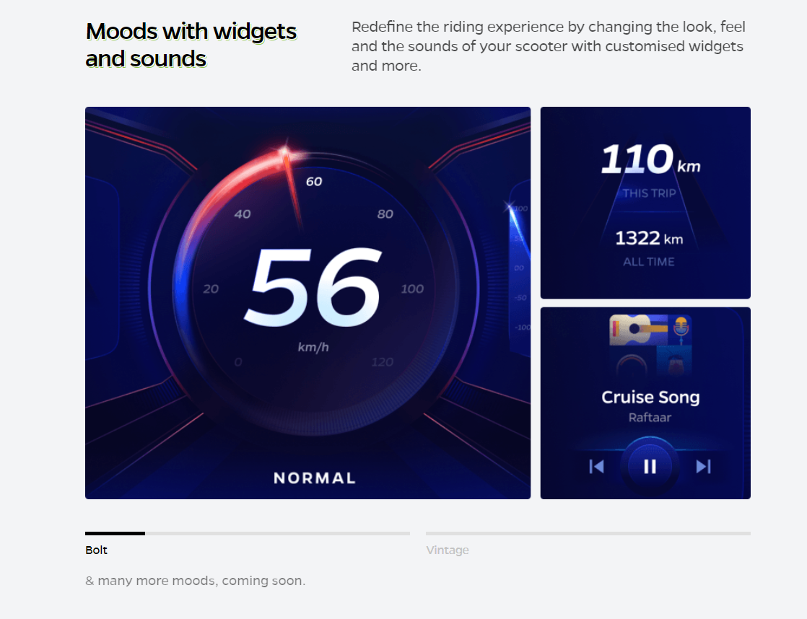

Conclusion:

* Website consist of lots of images and videos about the product
* Website theme is Black and White
* Website is not made in React\*
* For display: MoveOS\*\*

\*React is framework in JavaScript, which is helpful in frontend dev. If website has multiple webpages and having same UI elements. Otherwise, it is drawback of React.js

Example: YouTube Website

\*\*MoveOS is custom ROM/OS based on Android. We can called it ABOS (Android Based Operating System), because Android is open source. We have to get licence from google for Google Play Service for Smartphones/Android TV.

…………………………………………………………………………………………………………………

For display we can implement Android Auto, which is part of Google Play Service for Android.

Now today, No one from the competitor is providing this feature in 2-wheeler sector. So, we can implement it.

With the help of Android Auto, we can connect our android phone to the EV through wirely as well as wirelessly. And on the EV display we can use the following features:

* Calling
* Google Map
* Playing music from app installed in connected mobile eg: Spotify, YT music

Now for Apple users, we can implement the Apple CarPlay feature also.

<https://www.android.com/auto/>

<https://www.apple.com/in/ios/carplay/>